Python Programming Tasks

# Task 1: Removing Punctuation from a String

In this task, a string containing some extra punctuation marks is given. The goal is to remove all punctuation and keep only the alphanumeric characters. This is achieved by iterating through each character in the string and checking if it is alphanumeric. If the condition is true, the character is added to a new string.

## Explanation:

The variable 's' contains the string. A new empty string 'ind' is used to collect the cleaned characters. Using the 'isalnum()' method, only letters and digits are kept, and punctuation is removed.

## Output:

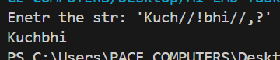

# Task 2: Sorting Words by First Character

This task focuses on sorting a list of words based on the ASCII values of their first characters. The sentence is split into words, and then bubble sort is applied to reorder the list alphabetically by their first letter in sortword function.  
In second sortletter function , the spaces are driven out then on all the alphabets bubble sort applied.

## Explanation:

The sentence is broken down into individual words using the split() function. By comparing ASCII values of the first character of each word, bubble sort swaps the positions until the words are arranged alphabetically.

## Output: First output statement shows the sorting by words and other statement shows the sort of letters.

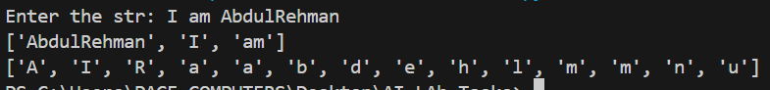

# Task 3: Validating a Credit Card Number

In this task, the program checks whether a given credit card number is valid or not using the Luhn algorithm. The last digit of the card is separated as the check digit. The remaining digits are reversed, doubled alternately, and adjusted if greater than 9. Finally, the sum is calculated and checked for divisibility by 10 to determine validity.

## Explanation:

The last digit (check digit) is stored separately. The rest of the number is reversed and each alternate digit is doubled. If doubling makes it greater than 9, 9 is subtracted. Finally, the total sum is checked. If the total plus the check digit is divisible by 10, the card is valid, otherwise invalid.

## Output:

For Valid card number  


For Invalid card number  
